**Tip Sheet: Stages of Change Model (Prochaska & DiClemente, 1983)**

**What is it?**

* This model describes six stages that people go through when they undertake a change: precontemplation, contemplation, preparation, action, relapse and maintenance.
* It is the most researched model of change, although most of the research has been in relation to addictions and health issues.
* Motivational interviewing techniques are used to help move clients through the stages of change.
* Key criticism: emphasize on discrete mutually exclusive stages.

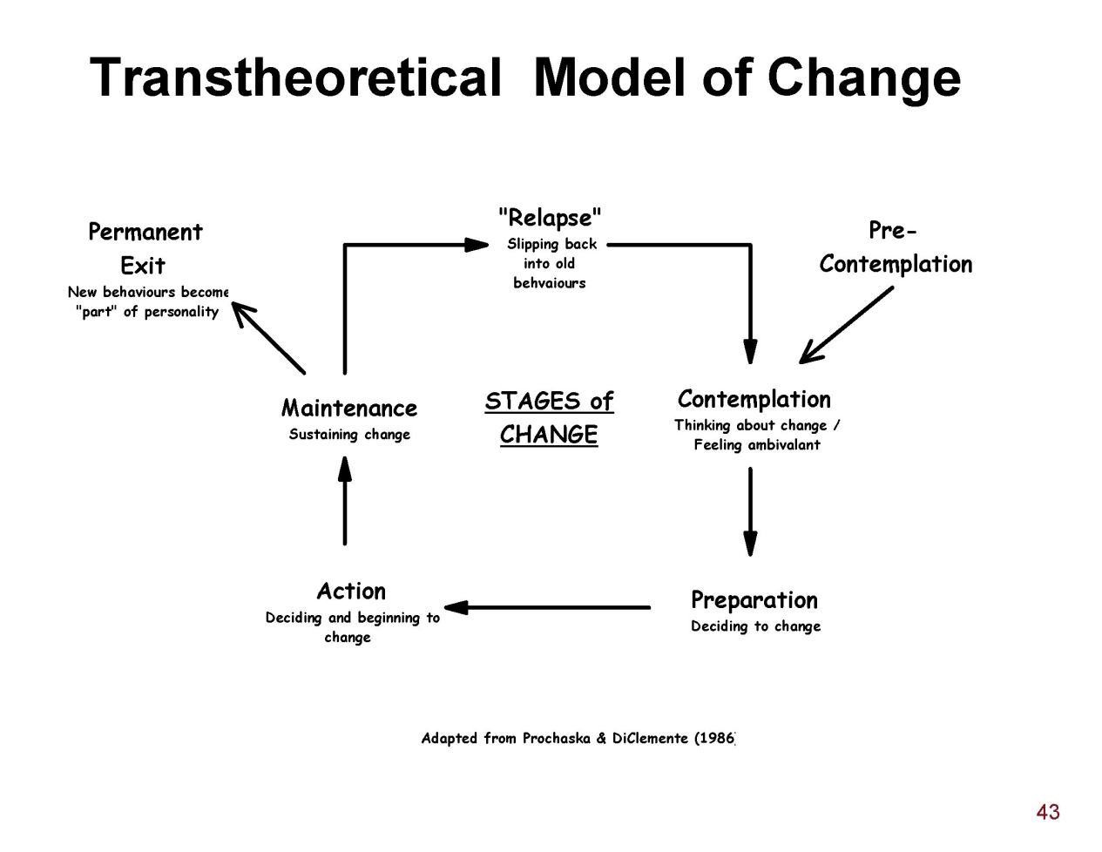

**Core Constructs of the Model:**

**Self-Efficacy:** Self-efficacy or confidence that one can make the change increases as the client moves through the stages of the model. It is important in the early stages to help the client increase self-efficacy.

**Decisional balance or weighing up the pros and cons of making a change:** In the early stages the cons of making the change outweigh the cons, however by the preparation stage this is reversed and the pros out weigh the cons. Helping the client explore pros and cons is essential to helping them move from the contemplation to preparation stage

|  |  |  |
| --- | --- | --- |
| **Stage of Change** | **Characteristics** | **Techniques** |
| Pre-contemplation | Not currently considering change | Encourage self-exploration and increasing self awareness especially re problem behaviors  Validate lack of readiness to change  Explain and personalize the risk |
| Contemplation | Ambivalent about change: Not considering change within the next month | Encourage evaluation of pros and cons of behavior change  Reflect ambivalence back to the client  Emphasize client choice and responsibility to make the change |
| Preparation | Some experience with change and are trying to change. Planning to act within 1month | Help explore different solutions  Identify and assist in problem solving  Help client identify social support  Develop any skills required for behavior change  Encourage small initial steps  Build confidence that client can make the change |
| Action | Practicing new behavior for 3-6 months | Focus on restructuring environment and social support to support change  Develop self-efficacy for dealing with obstacles  Acknowledge feelings of loss but emphasize the positive aspects of making the change |
| Maintenance | Continued commitment to new behavior. Post-6 months to 5 years | Dev plan to prevent relapse |
| Relapse | Resuming old behaviors | Evaluate trigger for relapse  Reframe relapse as a normal part of any change process  Build self efficacy and emphasized past success |

**References:**

**Prochaska, J. O., & DiClemente, C. C. (1983). Stages and processes of self-change of smoking: Toward an integrative model of change. *Journal of Consulting Clinical Psychology, 51*(3), 390-395.**

**Prochaska, J. O., Velicer, W. F., Rossi, J. S., Goldstein, M. G., Marcus, B. H., Rakowski, W., et al. (1994). Stages of change and decisional balance for 12 problem behaviours. *Health Psychology, 13*(1), 39-46.**